## Syntax Directed Translations

* Syntax Directed Definitions
* Implementing Syntax Directed Definitions
  + Dependency Graphs
  + S-Attributed Definitions
  + L-Attributed Definitions
* Translation Schemes

# Semantic Analysis

* **Semantic Analysis** computes additional information related to the meaning of the program once the syntactic structure is known.
* In typed languages as C, semantic analysis involves adding information to the symbol table and performing type checking.
* The information to be computed is beyond the capabilities of standard parsing techniques, therefore it is not regarded as syntax.
* As for Lexical and Syntax analysis, also for Semantic Analysis we need both a *Representation Formalism* and an *Implementation Mechanism*.
* As representation formalism this lecture illustrates what are called *Syntax Directed Translations*.

# Syntax Directed Translation: Intro

* The **Principle of Syntax Directed Translation** states that the meaning of an input sentence is related to its syntactic structure, i.e., to its Parse-Tree.
* By **Syntax Directed Translations** we indicate those formalisms for specify- ing translations for programming language constructs guided by context-free grammars.
  + We associate **Attributes** to the grammar symbols representing the language constructs.
  + Values for attributes are computed by **Semantic Rules** associated with grammar productions.

# Syntax Directed Translation: Intro (Cont.)

* Evaluation of Semantic Rules may:
  + Generate Code;
  + Insert information into the Symbol Table;
  + Perform Semantic Check;
  + Issue error messages;
  + etc.
* There are two notations for attaching semantic rules:

1. **Syntax Directed Definitions.** High-level specification hiding many implementation details (also called **Attribute Grammars**).
2. **Translation Schemes.** More implementation oriented: Indicate the order in which semantic rules are to be evaluated.

# Summary

* Syntax Directed Translations

## Syntax Directed Definitions

* Implementing Syntax Directed Definitions
  + Dependency Graphs
  + S-Attributed Definitions
  + L-Attributed Definitions
* Translation Schemes

# Syntax Directed Definitions

* **Syntax Directed Definitions** are a generalization of context-free grammars in which:

1. Grammar symbols have an associated set of **Attributes**;
2. Productions are associated with **Semantic Rules** for computing the values of attributes.

* Such formalism generates **Annotated Parse-Trees** where each node of the tree is a record with a field for each attribute (e.g., *X.a* indicates the attribute *a* of the grammar symbol *X*).

# Syntax Directed Definitions (Cont.)

* The value of an attribute of a grammar symbol at a given parse-tree node is defined by a semantic rule associated with the production used at that node.
* We distinguish between two kinds of attributes:

1. **Synthesized Attributes.** They are computed from the values of the attributes of the children nodes.
2. **Inherited Attributes.** They are computed from the values of the attributes of both the siblings and the parent nodes.

# Form of Syntax Directed Definitions

* Each production, *A* → *α*, is associated with a set of semantic rules:

*b* := *f* (*c*1*, c*2*, . . . , ck*), where *f* is a function and either

1. *b* is a **synthesized** attribute of *A*, and *c*1*, c*2*, . . . , ck* are attributes of the grammar symbols of the production, or
2. *b* is an **inherited** attribute of a grammar symbol in *α*, and *c*1*, c*2*, . . . , ck*

are attributes of grammar symbols in *α* or attributes of *A*.

* **Note.** Terminal symbols are assumed to have synthesized attributes supplied by the lexical analyzer.
* Procedure calls (e.g. *print* in the next slide) define values of *Dummy* synthesized attributes of the non terminal on the left-hand side of the production.

# Syntax Directed Definitions: An Example

* **Example.** Let us consider the Grammar for arithmetic expressions. The Syntax Directed Definition associates to each non terminal a synthesized attribute called *val*.

|  |  |
| --- | --- |
| PRODUCTION | SEMANTIC RULE |
| *L* → *E*n | *print*(*E.val*) |
| *E* → *E*1 + *T* | *E.val* := *E*1*.val* + *T.val* |
| *E* → *T* | *E.val* := *T.val* |
| *T* → *T*1 ∗ *F* | *T.val* := *T*1*.val* ∗ *F.val* |
| *T* → *F* | *T.val* := *F.val* |
| *F* → (*E*) | *F.val* := *E.val* |
| *F* → digit | *F.val* :=digit.*lexval* |

# S-Attributed Definitions

**Definition.** An **S-Attributed Definition** is a Syntax Directed Definition that uses only synthesized attributes.

* **Evaluation Order.** Semantic rules in a S-Attributed Definition can be evaluated by a bottom-up, or PostOrder, traversal of the parse-tree.
* **Example.** The above arithmetic grammar is an example of an S-Attributed Definition. The annotated parse-tree for the input 3*5+4n is:

*L*

*E.val* = 19 n

*E.val* = 15 + *T.val* = 4

*T.val* = 15 *F.val* = 4 *T.val* = 3 * *F.val* = 5 digit.*lexval*= 4 *F.val* = 3 digit.*lexval*= 5

digit.*lexval*= 3

# Inherited Attributes

* **Inherited Attributes** are useful for expressing the dependence of a construct on the context in which it appears.
* It is always possible to rewrite a syntax directed definition to use only synthesized attributes, but it is often more natural to use both synthesized and inherited attributes.
* **Evaluation Order.** Inherited attributes cannot be evaluated by a simple PreOrder traversal of the parse-tree:
  + Unlike synthesized attributes, the order in which the inherited attributes of the children are computed is important!!! Indeed:
    - Inherited attributes of the children can depend from both left and right siblings!

# Inherited Attributes: An Example

* **Example.** Let us consider the syntax directed definition with both inherited and synthesized attributes for the grammar for “type declarations”:

|  |  |
| --- | --- |
| PRODUCTION | SEMANTIC RULE |
| *D* → *TL* | *L.in* := *T.type* |
| *T* →int | *T.type* :=*integer* |
| *T* →real | *T.type* :=*real* |
| *L* → *L*1*,* id | *L*1*.in* := *L.in*; *addtype(*id*.entry, L.in)* |
| *L* → id | *addtype(*id*.entry, L.in)* |

* The non terminal *T* has a synthesized attribute, *type*, determined by the keyword in the declaration.
* The production *D* → *TL* is associated with the semantic rule *L.in* :=

*T.type* which set the *inherited* attribute *L.in*.

* Note: The production *L* → *L*1*,* id distinguishes the two occurrences of *L*.
* Inherited attributes that *do not depend from right children* can be evaluated by a classical PreOrder traversal.
* The annotated parse-tree for the input real id1, id2, id3 is:

*D*

*T.type* = *real L.in*

real *L.in* , id3

*L.in* , id2 id1

* Inherited attributes that *do not depend from right children* can be evaluated by a classical PreOrder traversal.
* The annotated parse-tree for the input real id1, id2, id3 is:

*D*

*T.type* = *real L.in*= real

real *L.in* , id3

*L.in* , id2 id1

* Inherited attributes that *do not depend from right children* can be evaluated by a classical PreOrder traversal.
* The annotated parse-tree for the input real id1, id2, id3 is:

*D*

*T.type* = *real L.in*= real

real *L.in*= real , id3

*L.in* , id2 id1

* Inherited attributes that *do not depend from right children* can be evaluated by a classical PreOrder traversal.
* The annotated parse-tree for the input real id1, id2, id3 is:

*D*

*T.type* = *real L.in*= real

real *L.in*= real , id3

*L.in*= real , id2 id1

* *L.in* is then inherited top-down the tree by the other *L*-nodes.
* At each *L*-node the procedure *addtype* inserts into the symbol table the type of the identifier.

# Summary

* Syntax Directed Translations
* Syntax Directed Definitions

## Implementing Syntax Directed Definitions

* + **Dependency Graphs**
  + S-Attributed Definitions
  + L-Attributed Definitions
* Translation Schemes

# Dependency Graphs

* Implementing a Syntax Directed Definition consists primarily in finding an order for the evaluation of attributes
  + Each attribute value must be available when a computation is performed.
* **Dependency Graphs** are the most general technique used to evaluate syntax directed definitions with both synthesized and inherited attributes.
* A Dependency Graph shows the interdependencies among the attributes of the various nodes of a parse-tree.
  + There is a node for each attribute;
  + If attribute *b* depends on an attribute *c* there is a link from the node for *c*

to the node for *b* (*b* ← *c*).

* **Dependency Rule:** If an attribute *b* depends from an attribute *c*, then we need to fire the semantic rule for *c* first and then the semantic rule for *b*.

# Evaluation Order

* The evaluation order of semantic rules depends from a *Topological Sort*

derived from the dependency graph.

* **Topological Sort:** Any ordering *m*1*, m*2*, . . . , mk* such that if *mi* → *mj*

is a link in the dependency graph then *mi < mj*.

* Any topological sort of a dependency graph gives a valid order to evaluate the semantic rules.

# Dependency Graphs: An Example

* **Example.** Build the dependency graph for the parse-tree of real id1, id2, id3.

# Implementing Attribute Evaluation: General Remarks

* Attributes can be evaluated by building a dependency graph at compile-time and then finding a topological sort.

## Disavantages

1. This method fails if the dependency graph has a cycle: We need a test for non-circularity;
2. This method is time consuming due to the construction of the dependency graph.

* **Alternative Approach.** Design the syntax directed definition in such a way that attributes can be evaluated with a *fixed order* avoiding to build the dependency graph (method followed by many compilers).

# Strongly Non-Circular Syntax Directed Definitions

* **Strongly Non-Circular Syntax Directed Definitions.** Formalisms for which an attribute evaluation order can be fixed at compiler construction time.
  + They form a class that is less general than the class of non-circular definitions.
  + In the following we illustrate two kinds of strictly non-circular definitions:

*S-Attributed* and *L-Attributed Definitions*.

# Summary

* Syntax Directed Translations
* Syntax Directed Definitions

## Implementing Syntax Directed Definitions

* + Dependency Graphs

## S-Attributed Definitions

* + L-Attributed Definitions
* Translation Schemes

# Evaluation of S-Attributed Definitions

## Synthesized Attributes can be evaluated by a bottom-up parser as the input is being analyzed avoiding the construction of a dependency graph.

* The parser keeps the values of the synthesized attributes in its stack.
* Whenever a reduction *A* → *α* is made, the attribute for *A* is computed from the attributes of *α* which appear on the stack.
* Thus, a translator for an S-Attributed Definition can be simply implemented by extending the stack of an LR-Parser.

# Extending a Parser Stack

* Extra fields are added to the stack to hold the values of synthesized attributes.
* In the simple case of just one attribute per grammar symbol the stack has two fields: *state* and *val*

*val*

*state*

|  |  |
| --- | --- |
| *Z* | *Z.x* |
| *Y* | *Y.x* |
| *X* | *X.x* |
| *. . .* | *. . .* |

* The current top of the stack is indicated by the pointer *top*.
* Synthesized attributes are computed just before each reduction:
  + Before the reduction *A* → *XY Z* is made, the attribute for *A* is computed: *A.a* := *f* (*val*[*top*]*, val*[*top* − 1]*, val*[*top* − 2]).

# Extending a Parser Stack: An Example

* **Example.** Consider the S-attributed definitions for the arithmetic expres- sions. To evaluate attributes the parser executes the following code

|  |  |
| --- | --- |
| PRODUCTION | CODE |
| *L* → *E*n  *E* → *E*1 + *T*  *E* → *T*  *T* → *T*1 ∗ *F T* → *F*  *F* → (*E*)  *F* → digit | *print*(*val*[*top* − 1])  *val*[*ntop*] := *val*[*top*] + *val*[*top* − 2]  *val*[*ntop*] := *val*[*top*] ∗ *val*[*top* − 2]  *val*[*ntop*] := *val*[*top* − 1] |

* The variable *ntop* is set to the *new top of the stack*. After a reduction is done *top* is set to *ntop*: When a reduction *A* → *α* is done with |*α*| = *r*, then *ntop* = *top* − *r* + 1.
* During a shift action both the token and its value are pushed into the stack.

# Extending a Parser Stack: An Example (Cont.)

* The following Figure shows the moves made by the parser on input 3*5+4n.
  + Stack states are replaced by their corresponding grammar symbol;
  + 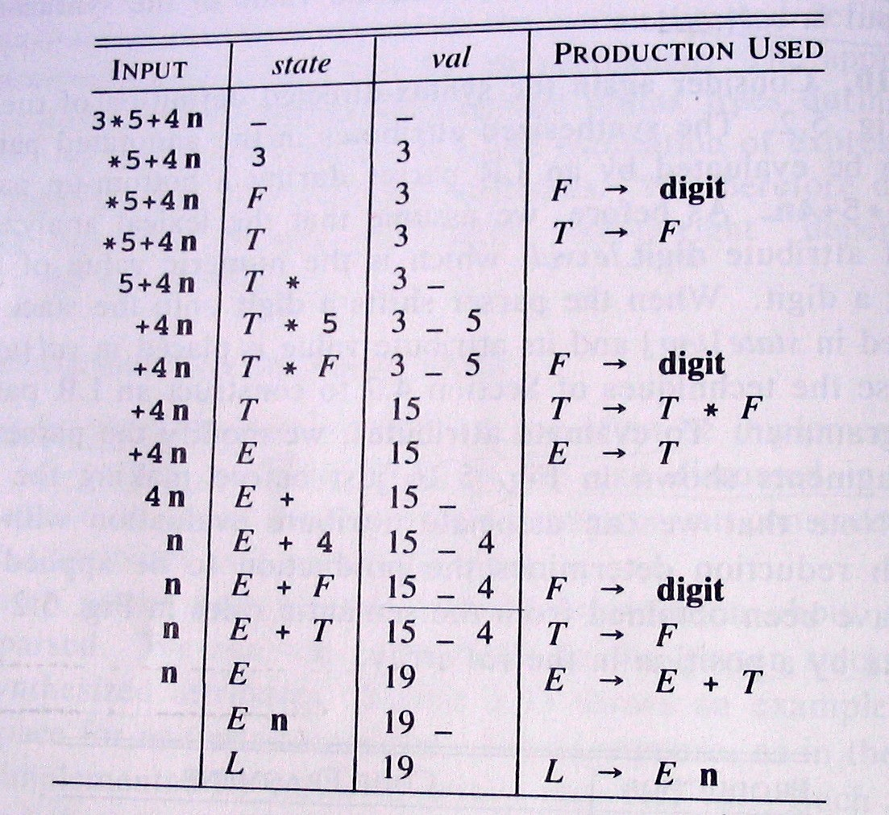Instead of the token digit the actual value is shown.

# Summary

* Syntax Directed Translations
* Syntax Directed Definitions

## Implementing Syntax Directed Definitions

* + Dependency Graphs
  + S-Attributed Definitions

## L-Attributed Definitions

* Translation Schemes

# L-Attributed Definitions

* **L-Attributed Definitions** contain both synthesized and inherited attributes but do not need to build a dependency graph to evaluate them.
* **Definition.** A syntax directed definition is *L-Attributed* if each *inherited attribute* of *Xj* in a production *A* → *X*1 *. . . Xj . . . Xn*, depends only on:

1. The attributes of the symbols to the **left** (this is what *L* in *L-Attributed*

stands for) of *Xj*, i.e., *X*1*X*2 *. . . Xj*−1, and

1. The *inherited* attributes of *A*.

* **Theorem.** Inherited attributes in L-Attributed Definitions can be computed by a PreOrder traversal of the parse-tree.

# Evaluating L-Attributed Definitions

## L-Attributed Definitions are a class of syntax directed definitions whose attributes can always be evaluated by single traversal of the parse-tree.

* The following procedure evaluate L-Attributed Definitions by mixing PostOrder (synthesized) and PreOrder (inherited) traversal.

## Algorithm: L-Eval(n: Node)

*Input:* Node of an annotated parse-tree.

*Output:* Attribute evaluation.

Begin

For each child *m* of *n*, from left-to-right Do Begin

Evaluate inherited attributes of *m*; L-Eval(m)

End;

Evaluate synthesized attributes of *n*

End.

# Summary

* Syntax Directed Translations
* Syntax Directed Definitions
* Implementing Syntax Directed Definitions
  + Dependency Graphs
  + S-Attributed Definitions
  + L-Attributed Definitions

## Translation Schemes

**Translation Schemes**

* **Translation Schemes** are more implementation oriented than syntax directed definitions since they **indicate the order** in which semantic rules and attributes are to be evaluated.
* **Definition.** A Translation Scheme is a context-free grammar in which

1. Attributes are associated with grammar symbols;
2. Semantic Actions are enclosed between braces {} and **are inserted within the right-hand side of productions.**

* Yacc uses Translation Schemes.

# Translation Schemes (Cont.)

* Translation Schemes deal with both synthesized and inherited attributes.
* Semantic Actions are treated as terminal symbols: Annotated parse-trees contain semantic actions as children of the node standing for the correspond- ing production.
* Translation Schemes are useful to evaluate L-Attributed definitions at parsing time (even if they are a general mechanism).

## An L-Attributed Syntax-Directed Definition can be turned into a Translation Scheme.

**Translation Schemes: An Example**

* Consider the Translation Scheme for the L-Attributed Definition for “type declarations”:

*D* → *T* {*L.in* := *T.type*} *L T* → int {*T.type* :=*integer*} *T* → real {*T.type* :=*real*}

*L* → {*L*1*.in* := *L.in*} *L*1*,* id {*addtype(*id*.entry, L.in)*}

*L* → id {*addtype(*id*.entry, L.in)*}

# Translation Schemes: An Example (Cont.)

* **Example (Cont).** The parse-tree with semantic actions for the input

real id1, id2, id3 is:

*D*

*T* {*L.in* := *T.type*} *L*

real {*T.type := real*} {*L*1*.in := L.in*} *L*1 , id3 {*addtype(*id3*.entry, L.in)*}

{*L*2*.in* := *L*1*.in*} *L*2 , id2 {*addtype(*id2*.entry, L*1*.in)*}

id1 {*addtype(*id1*.entry, L*2*.in)*}

## Traversing the Parse-Tree in depth-first order (PostOrder) we can evaluate the attributes.

**Design of Translation Schemes**

* When designing a Translation Scheme we must be sure that an attribute value is available when a semantic action is executed.

## When the semantic action involves only synthesized attributes: The action can be put at the end of the production.

* + **Example.** The following Production and Semantic Rule:

*T* → *T*1 ∗ *F T.val* := *T*1*.val* ∗ *F.val*

yield the translation scheme:

*T* → *T*1 ∗ *F* {*T.val* := *T*1*.val* ∗ *F.val*}

# Design of Translation Schemes (Cont.)

* **Rules for Implementing L-Attributed SDD’s.** If we have an L-Attibuted Syntax-Directed Definition we must enforce the following restrictions:

1. An inherited attribute for a symbol in the right-hand side of a production must be computed in an action before the symbol;
2. A synthesized attribute for the non terminal on the left-hand side can only be computed when all the attributes it references have been computed: The action is usually put at the end of the production.

# Compile-Time Evaluation of Translation Schemes

* Attributes in a Translation Scheme following the above rules can be computed at compile time similarly to the evaluation of S-Attributed Definitions.
* **Main Idea.** Starting from a Translation Scheme (with embedded actions) we introduce a transformation that makes all the actions occur at the right ends of their productions.
  + For each embedded semantic action we introduce a new *Marker* (i.e., a non terminal, say *M* ) with an empty production (*M* → *ǫ*);
  + The semantic action is attached at the end of the production *M* → *ǫ*.
* **Example.** Consider the following translation scheme:

*S* → *aA*{C*.*i = f(A*.*s)}*C*

*S* → *bAB*{C*.*i = f(A*.*s)}*C*

*C* → *c*{*C.s* = *g*(*C.i*)}

Then, we add new markers *M*1*, M*2 with:

*S* → *aA*M1*C S* → *bAB*M2*C*

M1 → *ǫ* {*M*1*.s* := *f* (*val*[*top*])}

M2 → *ǫ* {*M*2*.s* := *f* (*val*[*top* − 1])}

*C* → *c* {*C.s* := *g*(*val*[*top* − 1])}

The inherited attribute of *C* is the synthesized attribute of either *M*1 or *M*2: The value of *C.i* is *always* in *val*[*top -1*] when *C* → *c* is applied.

General rules to compute translations schemes during bottom-up parsing assum- ing an L-attributed grammar.

* For every production *A* → *X*1 *. . . Xn* introduce *n* new markers

*M*1*, . . . , Mn* and replace the production by *A* → *M*1*X*1 *. . . MnXn*.

* Thus, we know the position of every synthesized and inherited attribute of

*Xj* and *A*:

1. *Xj.s* is stored in the *val* entry in the parser stack associated with *Xj*;
2. *Xj.i* is stored in the *val* entry in the parser stack associated with *Mj*;
3. *A.i* is stored in the *val* entry in the parser stack immediately before the position storing *M*1.

* **Remark 1.** Since there is only one production for each marker a grammar remains LL(1) with addition of markers.
* **Remark 2.** Adding markers to an LR(1) Grammar can introduce conflicts for not L-Attributed SDD’s!!!

**Example.** Computing the inherited attribute *Xj.i* after reducing with *Mj* → *ǫ*.

*top*→

|  |  |
| --- | --- |
|  |  |
| *Mj* | *Xj.i* |
| *Xj*−1 | *Xj*−1*.s* |
| *Mj*−1 | *Xj*−1*.i* |
| *. . .* | *. . .* |
| *X*1 | *X*1*.s* |
| *M*1 | *X*1*.i* |
| *MA* | *A.i* |
|  |  |
|  |  |

(*top-2j+2*)→ (*top-2j*)→

* *A.i* is in *val*[*top* − 2*j* + 2];
* *X*1*.i* is in *val*[*top* − 2*j* + 3];
* *X*1*.s* is in *val*[*top* − 2*j* + 4];
* *X*2*.i* is in *val*[*top* − 2*j* + 5];
* and so on.

# Summary of Lecture VIII

* Syntax Directed Translations
* Syntax Directed Definitions
* Implementing Syntax Directed Definitions
  + Dependency Graphs
  + S-Attributed Definitions
  + L-Attributed Definitions
* Translation Schemes